Notes App Documentation :

Setup -

* I am using spring boot 3.2. Spring boot 3.2 supports minimum java 17.
* Install eclipse IDE. We can use STS, eclipse or intellij Ide etc.
* Create project <https://start.spring.io/> also add required dependency
* After downloading the project import project in eclipse.
* Install Postman for API testing
* Install PostgreSQL

Implementation -

1. Pom.xml

* Add JWT token related maven dependency
* Add JPA maven dependency
* Add postgre sqldependency
* Add JSP maven dependency

1. Pom.xml

* Add database connectivity
* Add hibernate dialect
* Add spring JSP view resolver

#Database connectivity

spring.datasource.url= jdbc:postgresql://localhost:5432/note_app

spring.datasource.username= postgres

spring.datasource.password= Admin

#Create table if not availabe

spring.jpa.properties.hibernate.jdbc.lob.non_contextual_creation= true

spring.jpa.properties.hibernate.dialect= org.hibernate.dialect.PostgreSQLDialect

spring.jpa.hibernate.ddl-auto= update

#Console the query

spring.jpa.properties.hibernate.format_sql=true

spring.jpa.show-sql=true

server.port = 8080

spring.mvc.view.prefix: /WEB-INF/jsp/

spring.mvc.view.suffix: .jsp

1. Database schema

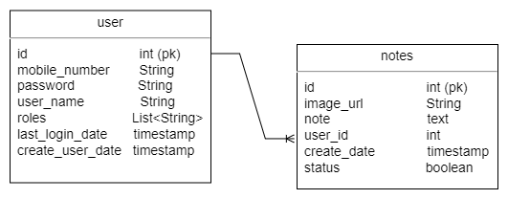

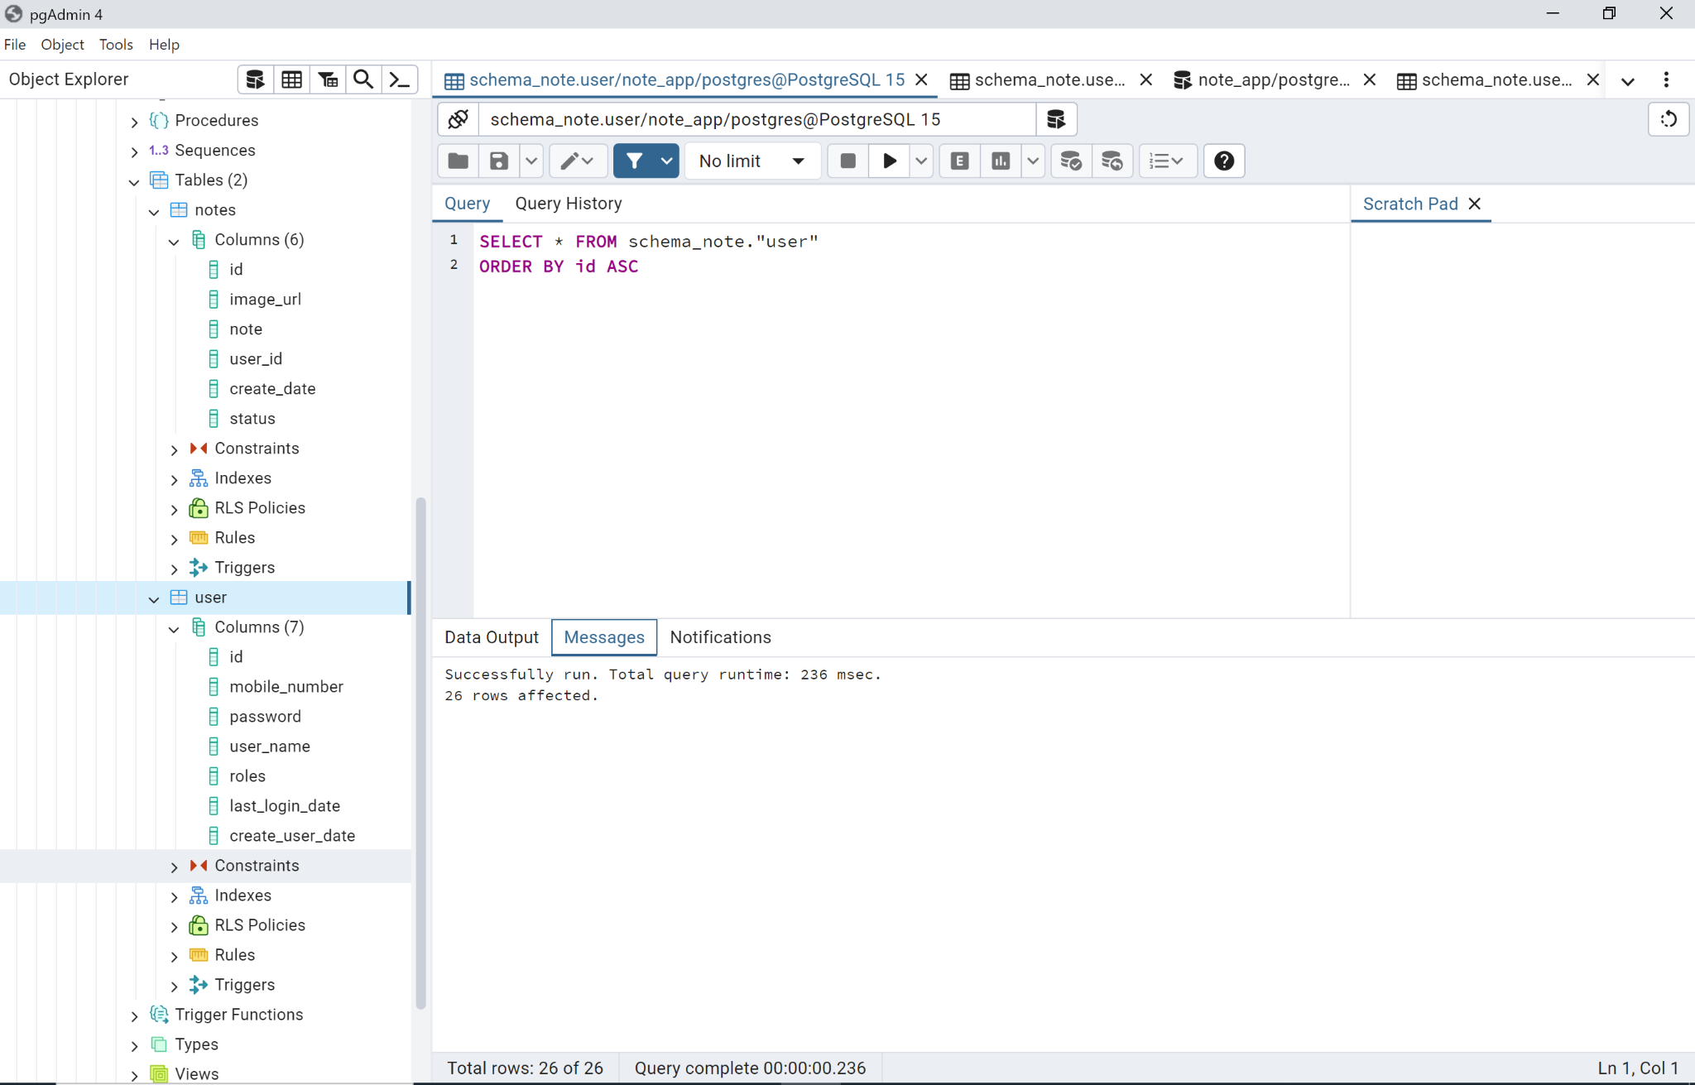

1. Status code

* 400 exception occurred
* 401 all fields are required
* 200 success
* 404 page not found
* 500 internal server error

1. Postman API

* Create new user

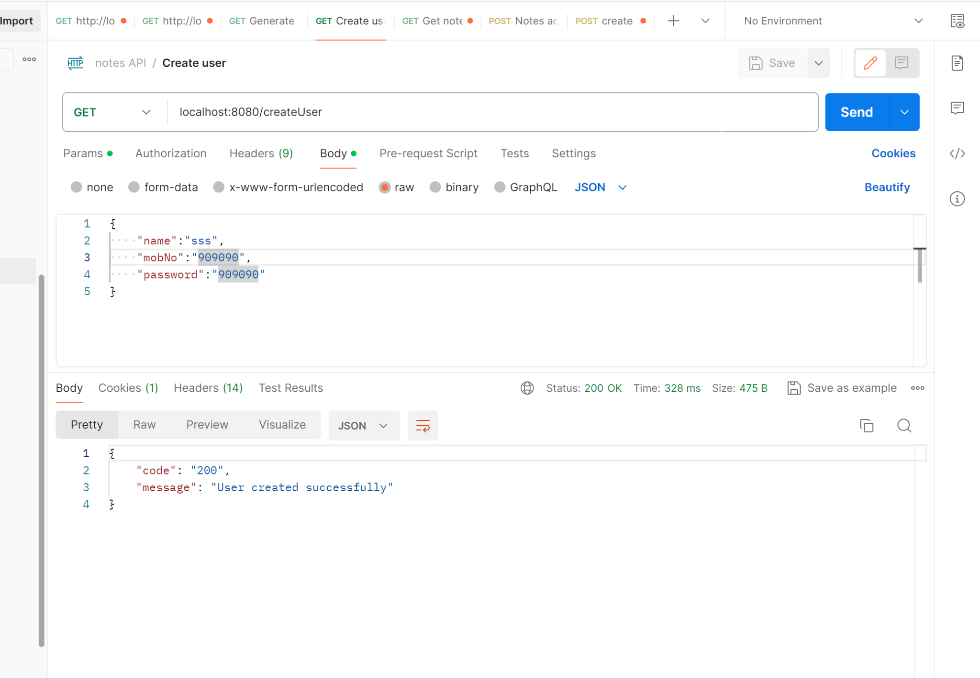

* Login user and generate token

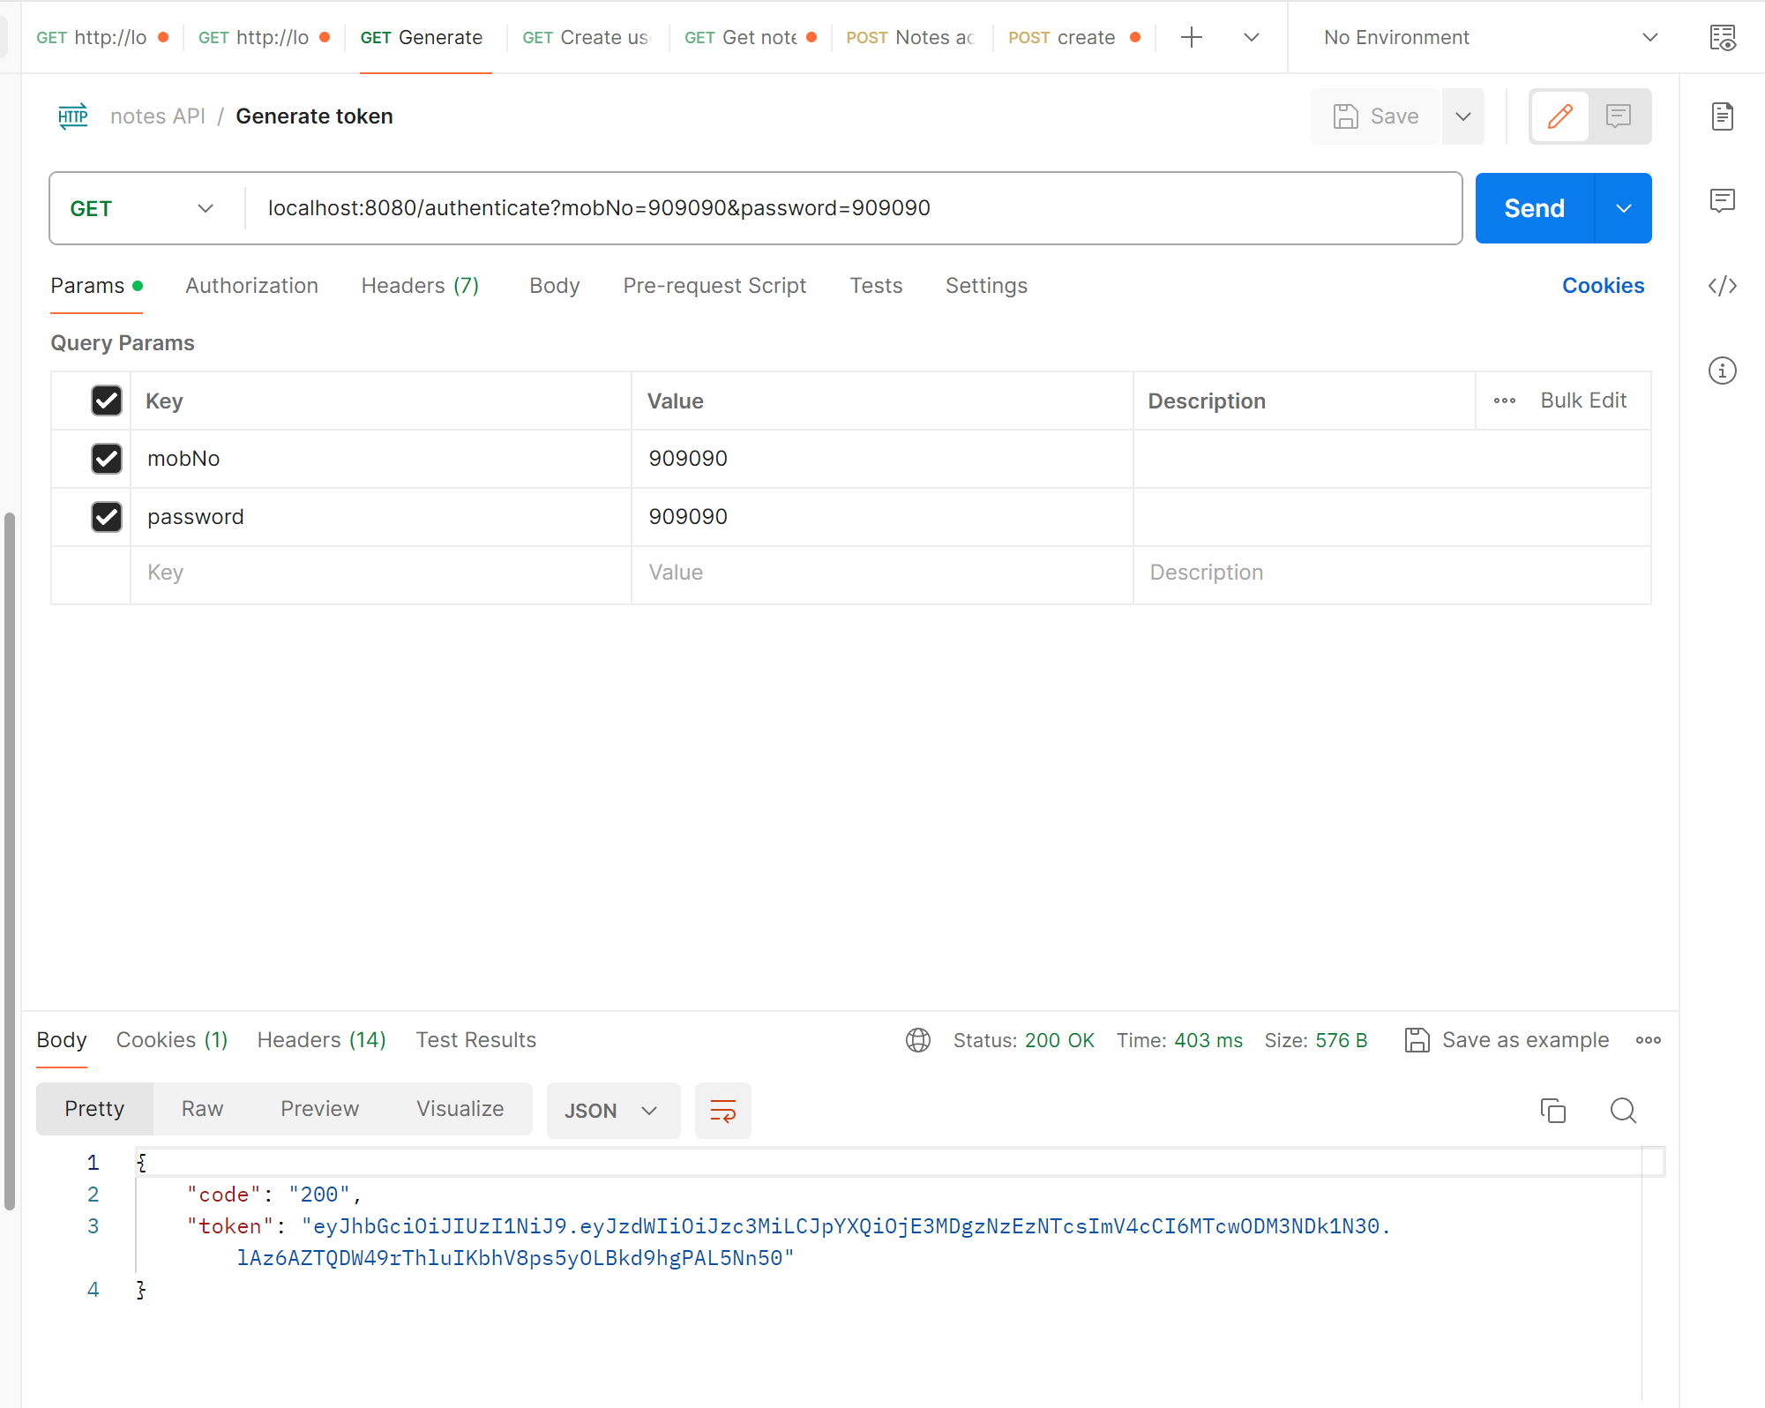

* Create notes

1. Token should be valid
2. Image should be attached
3. If token expired generate new token

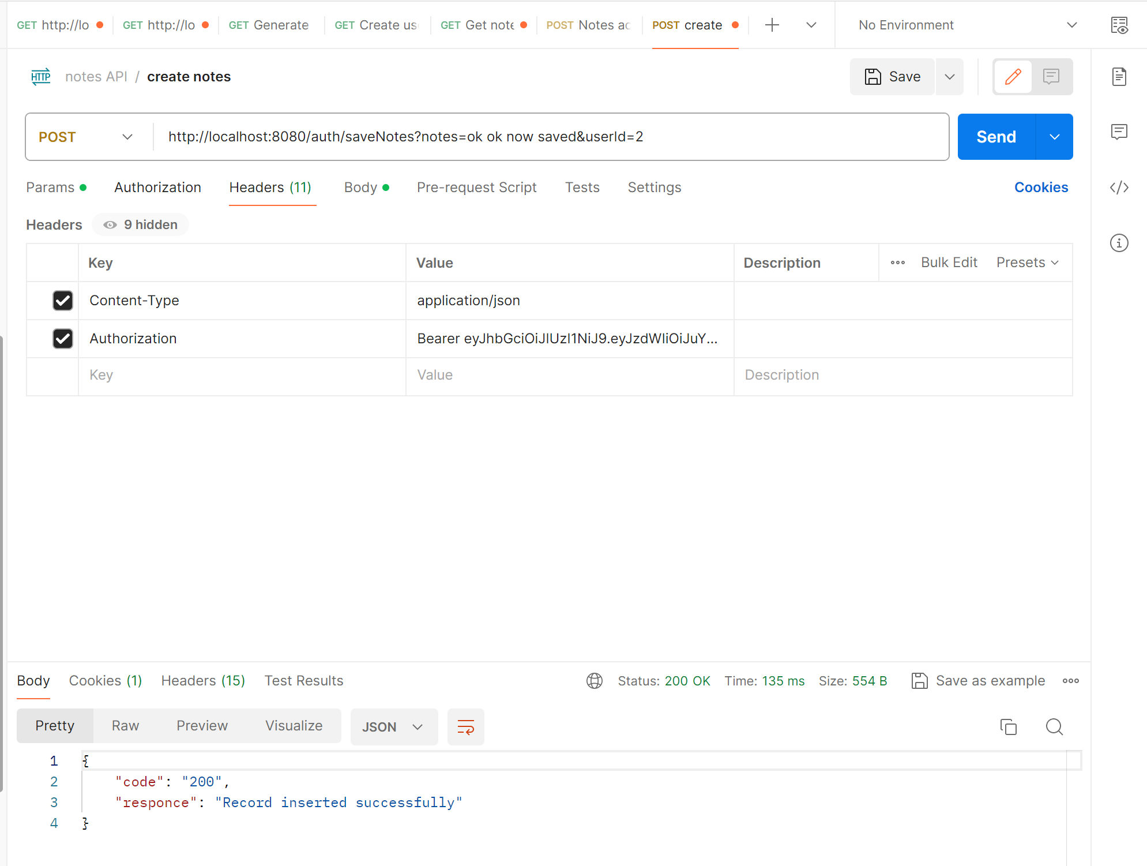

* Notes access control

1.If status is true means this is private

2. If Status is false this is public

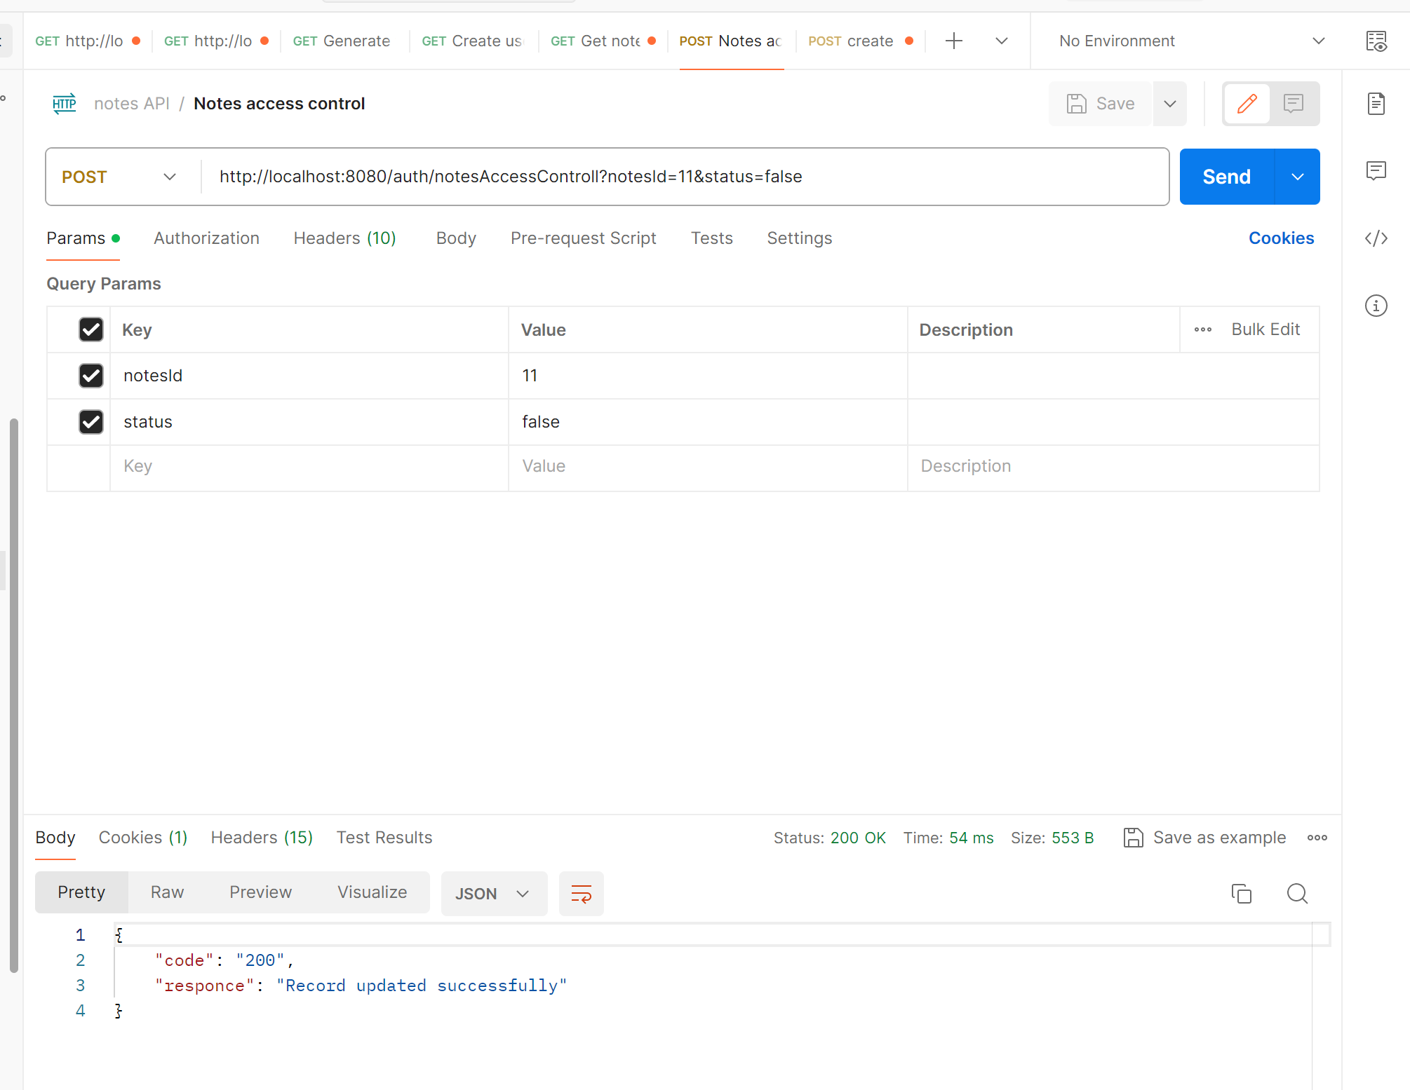

* Get user notes and public notes also

